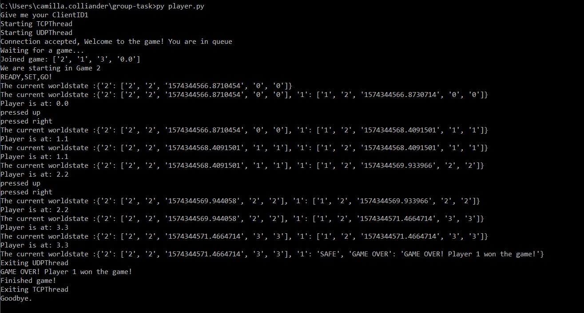

Here we start player 1. First the system asks for a client ID. Then the threads start and we try to make a connection to server. We get a welcome msg, and we start waiting for a game. The wait will be max 2 minutes.

We have Joined a game. [2 = Game instance ID, 1 = Player ID, 3 =The upcoming msg length, ‘0.0’ = starting coordinates

We get the worldstate from the server. Push some arrow buttons and send them to server. The server decides where we have moved.

We see that we lost. The treasure was at x=4, y=4 and Player 1 got there first.

PLAYER 1

**PLAYER 2**

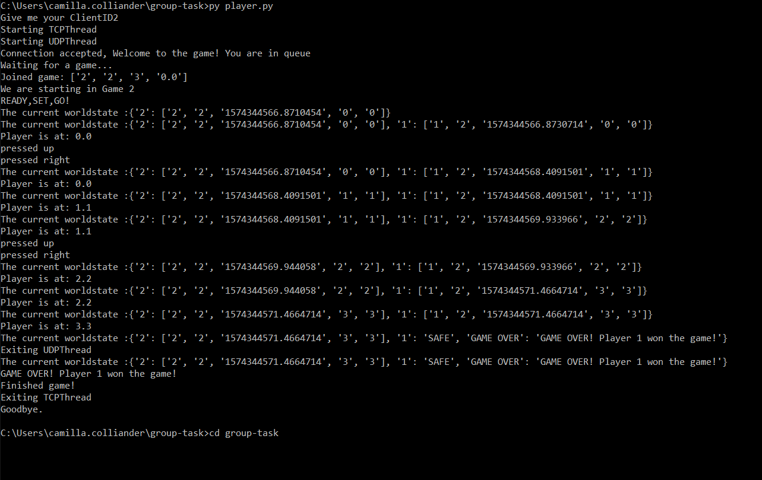

The 2 starting messages have been sent and the game can start. We start listening to user input via UDP Thread.

We see that we WON! The treasure was at x=4, y=4 and we got there first!

We have Joined a game. [2 = Game instance ID, 2 = Player ID, 3 =The upcoming msg length, ‘0.0’ = starting coordinates

Here we start Player 2. First the system asks for a client ID. Then the threads start and we try to make a connection to server. We get a welcome msg, and we start waiting for a game. The wait will be max 2 minutes.

We get the worldstate from the server. Push some arrow buttons and send them to server. The server decides where we have moved.

SERVER PART 1

**In Worldstate-dictionary** keys are the player ID’s and the values are the most recent clientmsg that we have gotten.

**The client msg contains**: player ID, Gmae instance ID, timestamp, x and y coordinates.

We start the server and select a location to hide the treasure 4.4 . The threads start and we listen to connections. We need 2 to begin the game. When we get the first connection we ask it to wait and sent a welcoming msg to both players when we have received 2 connections.

SERVER PART 2

We periodically send to all players the current worldstate that contains the updated coordinates of all players. When one of the players reach the treasure at 4.4, we send a final worldstate that ends the game ween above. Then we close threads and end the game.